Vector Projection
# Source: AI Source: Provided by: [Data Path: Persons Table -> ID Column: 1, Name_En Column: Motasem Essam] -> From: [ChatGPT] on [7/25/2026]

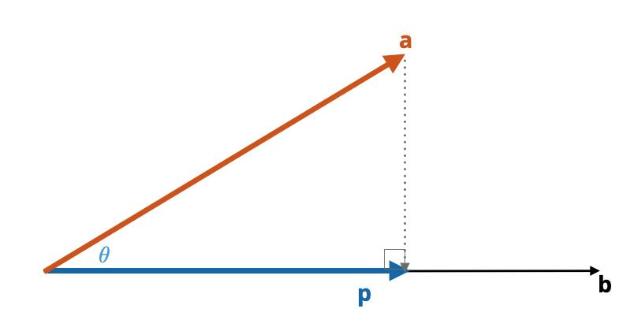
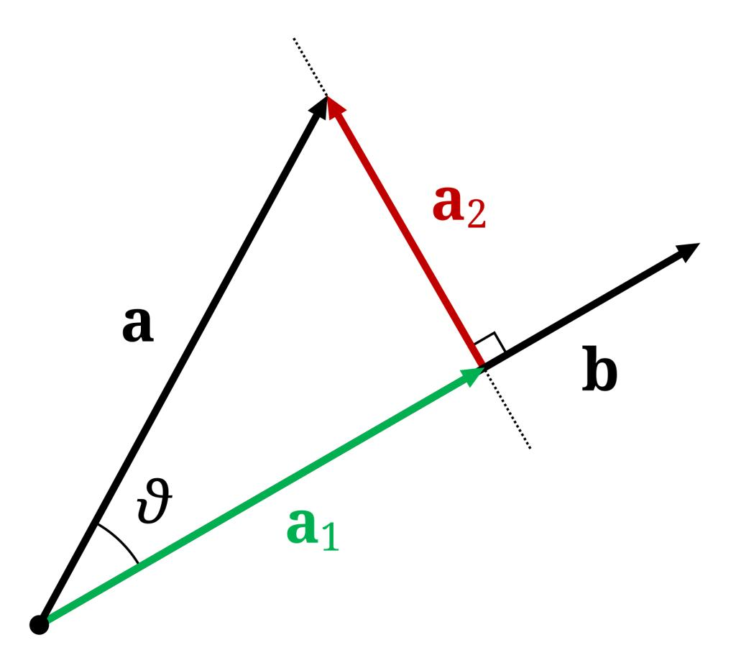
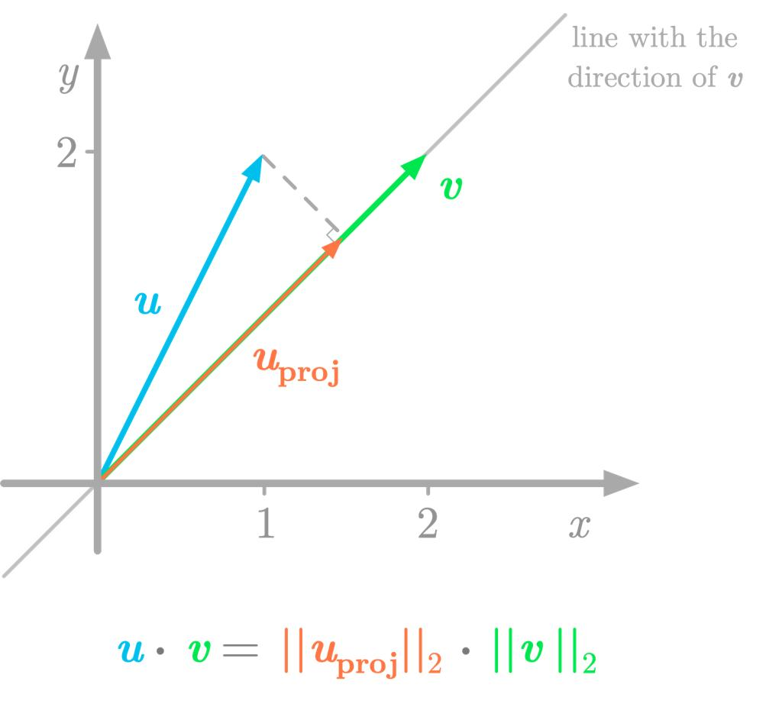

Definition
# Source: AI Source: Provided by: [Data Path: Persons Table -> ID Column: 1, Name_En Column: Motasem Essam] -> From: [ChatGPT] on [7/25/2026]
Vector projection is the process of finding the component of one vector that lies in the direction of another vector.
If vector $a$ is projected orthogonally onto vector $b$, the result is a vector that:
- lies parallel to $b$,
- represents the component of $a$ in the direction of $b$,
- and has a perpendicular remainder relative to $b$.
The vector projection of $a$ onto $b$ is:
$\boxed{{proj}_{b}(a)=\frac{a⋅b}{∥b∥^{2}}b}$
$${proj}_{b}(a)=\frac{a⋅b}{{\left\|b\right\|}^{2}}b$$
$$a=p+r, r⟂b$$
$${comp}_{b}(a)=6cos({55}^{∘})=3.4$$
The acute angle gives a positive component, so the projection points with b
$$θ$$
°

$$θ$$
Adjust the angle between vectors a and b. The diagram updates the perpendicular foot, projection vector, and signed scalar component.
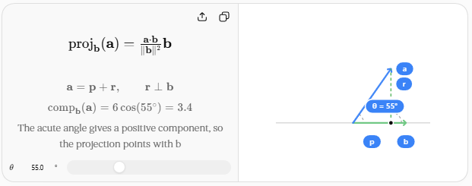

Purpose
# Source: AI Source: Provided by: [Data Path: Persons Table -> ID Column: 1, Name_En Column: Motasem Essam] -> From: [ChatGPT] on [7/25/2026]
Vector projection is used to:
- Find the component of a vector in a particular direction.
- Resolve vectors into parallel and perpendicular components.
- Calculate work done by a force.
- Find distances between geometric objects.
- Analyze motion and forces in physics.
- Solve problems involving lines and planes.
- Connect vectors with trigonometry.
- Calculate the closest point on a line.

Basic Configuration
# Source: AI Source: Provided by: [Data Path: Persons Table -> ID Column: 1, Name_En Column: Motasem Essam] -> From: [ChatGPT] on [7/25/2026]
Suppose we have two vectors:
$$a$$
and
$$b$$
We want to project $a$ onto $b$.
The projection is written:
$${proj}_{b}(a)$$
The projected vector lies along the direction of $b$.
The difference between the original vector and its projection is perpendicular to $b$.
Therefore:
$$\boxed{a={proj}_{b}(a)+a_{⟂}}$$
where:
$$a_{⟂}$$
is the component perpendicular to $b$.

Mathematical Representation

Vector Projection Formula
# Source: AI Source: Provided by: [Data Path: Persons Table -> ID Column: 1, Name_En Column: Motasem Essam] -> From: [ChatGPT] on [7/25/2026]
The standard formula is:
$$\boxed{{proj}_{b}(a)=\frac{a⋅b}{∥b∥^{2}}b}$$
where:
- $a$ = vector being projected
- $b$ = target vector
- $a⋅b$ = dot product
- $∥b∥$ = magnitude of $b$
The denominator must not be zero:
$$b≠0$$

Dot Product Connection
# Source: AI Source: Provided by: [Data Path: Persons Table -> ID Column: 1, Name_En Column: Motasem Essam] -> From: [ChatGPT] on [7/25/2026]
The dot product is:
$$a⋅b=∥a∥∥b∥cosθ$$
where $θ$ is the angle between the vectors.
Substituting into the projection formula:
$${proj}_{b}(a)=\frac{∥a∥∥b∥cosθ}{∥b∥^{2}}b$$
This simplifies to:
$${proj}_{b}(a)=∥a∥cosθ\frac{b}{∥b∥}$$
Thus, the length of the projection is:
$$\boxed{∥{proj}_{b}(a)∥=∥a∥|cosθ|}$$
This is the vector form of the trigonometric projection formula.

Scalar Projection
# Source: AI Source: Provided by: [Data Path: Persons Table -> ID Column: 1, Name_En Column: Motasem Essam] -> From: [ChatGPT] on [7/25/2026]
The scalar projection gives only the signed length of the component of $a$ along $b$.
It is:
$$\boxed{{comp}_{b}(a)=\frac{a⋅b}{∥b∥}}$$
Using the dot-product formula:
$$\boxed{{comp}_{b}(a)=∥a∥cosθ}$$
Difference
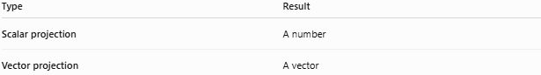
Type | Result
Scalar projection | A number
Vector projection | A vector

Example 1 — Simple Vector Projection
# Source: AI Source: Provided by: [Data Path: Persons Table -> ID Column: 1, Name_En Column: Motasem Essam] -> From: [ChatGPT] on [7/25/2026]
Let:
$$a=(3,4)$$
and:
$$b=(1,0)$$
First calculate the dot product:
$a⋅b=(3)(1)+(4)(0)$ $=3$
Magnitude squared of $b$:
$$∥b∥^{2}=1^{2}+0^{2}=1$$
Therefore:
${proj}_{b}(a)=\frac{3}{1}(1,0)$ $\boxed{{proj}_{b}(a)=(3,0)}$
So the horizontal component of $(3,4)$ is:
$$\boxed{(3,0)}$$
The perpendicular component is:
$a_{⟂}=(3,4)-(3,0)$ $\boxed{a_{⟂}=(0,4)}$

Example 2 — Projection onto a Non-Unit Vector
# Source: AI Source: Provided by: [Data Path: Persons Table -> ID Column: 1, Name_En Column: Motasem Essam] -> From: [ChatGPT] on [7/25/2026]
Let:
$$a=(2,3)$$
and:
$$b=(4,0)$$
Calculate:
$a⋅b=(2)(4)+(3)(0)$ $=8$
Also:
$$∥b∥^{2}=4^{2}+0^{2}=16$$
Therefore:
${proj}_{b}(a)=\frac{8}{16}(4,0)$ $=\frac{1}{2}(4,0)$ $\boxed{{proj}_{b}(a)=(2,0)}$
Notice that the magnitude of $b$ does not change the final geometric projection direction.

Example 3 — Perpendicular Vectors
# Source: AI Source: Provided by: [Data Path: Persons Table -> ID Column: 1, Name_En Column: Motasem Essam] -> From: [ChatGPT] on [7/25/2026]
Suppose:
$$a=(2,3)$$
and:
$$b=(3,-2)$$
Their dot product is:
$a⋅b=(2)(3)+(3)(-2)$ $=6-6$ $=0$
Therefore:
$$\boxed{{proj}_{b}(a)=0}$$
This occurs because the vectors are perpendicular.
In general:
$$\boxed{a⟂b⇔a⋅b=0}$$

Example 4 — Parallel Vectors
# Source: AI Source: Provided by: [Data Path: Persons Table -> ID Column: 1, Name_En Column: Motasem Essam] -> From: [ChatGPT] on [7/25/2026]
Suppose:
$$a=(2,4)$$
and:
$$b=(1,2)$$
The vectors are parallel.
The projection of $a$ onto $b$ is therefore the entire vector $a$:
$$\boxed{{proj}_{b}(a)=(2,4)}$$
This is because:
$$θ=0^{∘}$$
and:
$$cos0^{∘}=1$$

Acute, Right, and Obtuse Angles
# Source: AI Source: Provided by: [Data Path: Persons Table -> ID Column: 1, Name_En Column: Motasem Essam] -> From: [ChatGPT] on [7/25/2026]
The dot product determines the direction of the scalar projection.

Acute angle
# Source: AI Source: Provided by: [Data Path: Persons Table -> ID Column: 1, Name_En Column: Motasem Essam] -> From: [ChatGPT] on [7/25/2026]
If:
$$0^{∘}<θ<{90}^{∘}$$
then:
$$a⋅b>0$$
The projection points in the same direction as $b$.

Right angle
# Source: AI Source: Provided by: [Data Path: Persons Table -> ID Column: 1, Name_En Column: Motasem Essam] -> From: [ChatGPT] on [7/25/2026]
If:
$$θ={90}^{∘}$$
then:
$$a⋅b=0$$
The projection is:
$$\boxed{0}$$

Obtuse angle
# Source: AI Source: Provided by: [Data Path: Persons Table -> ID Column: 1, Name_En Column: Motasem Essam] -> From: [ChatGPT] on [7/25/2026]
If:
$${90}^{∘}<θ<{180}^{∘}$$
then:
$$a⋅b<0$$
The projection points in the opposite direction to $b$.

Projection onto a Unit Vector
# Source: AI Source: Provided by: [Data Path: Persons Table -> ID Column: 1, Name_En Column: Motasem Essam] -> From: [ChatGPT] on [7/25/2026]
If $u$ is a unit vector:
$$∥u∥=1$$
then the formula becomes simpler:
$$\boxed{{proj}_{u}(a)=(a⋅u)u}$$
The scalar projection is simply:
$$\boxed{a⋅u}$$
This is one reason unit vectors are useful when resolving vectors into components.

Perpendicular Component
# Source: AI Source: Provided by: [Data Path: Persons Table -> ID Column: 1, Name_En Column: Motasem Essam] -> From: [ChatGPT] on [7/25/2026]
Once the projection is known, the perpendicular component can be found by subtraction.
$$\boxed{a_{⟂}=a-{proj}_{b}(a)}$$
Therefore:
$$\boxed{a={proj}_{b}(a)+a_{⟂}}$$
and:
$$\boxed{a_{⟂}⟂b}$$

Projection in a Triangle
# Source: AI Source: Provided by: [Data Path: Persons Table -> ID Column: 1, Name_En Column: Motasem Essam] -> From: [ChatGPT] on [7/25/2026]
Vector projection is also useful in triangle geometry.
Suppose:
$$\vec{AB}$$
is projected onto:
$$\vec{AC}$$
Then:
$${proj}_{\vec{AC}}(\vec{AB})$$
gives the component of $AB$ in the direction of $AC$.
If the angle between $AB$ and $AC$ is $A$, the scalar projection is:
$$\boxed{ABcosA}$$
This is exactly the same geometric idea as projecting a triangle side onto another direction.

Projection and Trigonometry
# Source: AI Source: Provided by: [Data Path: Persons Table -> ID Column: 1, Name_En Column: Motasem Essam] -> From: [ChatGPT] on [7/25/2026]
The connection can be summarized as:
$$\boxed{\text{Scalar Projection}=∥a∥cosθ}$$
while the vector projection is:
$$\boxed{\text{Vector Projection}=∥a∥cosθ\frac{b}{∥b∥}}$$
So:
Trigonometry gives the magnitude of the component, while vector projection gives both its magnitude and direction.

Projection and Orthogonality
# Source: AI Source: Provided by: [Data Path: Persons Table -> ID Column: 1, Name_En Column: Motasem Essam] -> From: [ChatGPT] on [7/25/2026]
A fundamental property is:
$$\boxed{\left(a-{proj}_{b}(a)\right)⋅b=0}$$
This means the remaining component is perpendicular to the target vector.
Therefore:
$$a=a_{∥}+a_{⟂}$$
where:
$$a_{∥}={proj}_{b}(a)$$
and:
$$a_{⟂}=a-a_{∥}$$

Applications

Physics
# Source: AI Source: Provided by: [Data Path: Persons Table -> ID Column: 1, Name_En Column: Motasem Essam] -> From: [ChatGPT] on [7/25/2026]
A force can be projected onto the direction of motion:
$$F_{∥}=Fcosθ$$
This is important in calculating work:
$$W=Fdcosθ$$

Geometry
# Source: AI Source: Provided by: [Data Path: Persons Table -> ID Column: 1, Name_En Column: Motasem Essam] -> From: [ChatGPT] on [7/25/2026]
Projection can find:
- perpendicular distances,
- closest points,
- components of sides,
- relationships between lines.

Computer Graphics
# Source: AI Source: Provided by: [Data Path: Persons Table -> ID Column: 1, Name_En Column: Motasem Essam] -> From: [ChatGPT] on [7/25/2026]
Vectors are projected onto:
- surfaces,
- camera directions,
- coordinate axes.

Engineering
# Source: AI Source: Provided by: [Data Path: Persons Table -> ID Column: 1, Name_En Column: Motasem Essam] -> From: [ChatGPT] on [7/25/2026]
Projection is used to resolve forces into:
$$F_{x}$$
and:
$$F_{y}$$
components.

Navigation
# Source: AI Source: Provided by: [Data Path: Persons Table -> ID Column: 1, Name_En Column: Motasem Essam] -> From: [ChatGPT] on [7/25/2026]
A velocity vector can be projected onto a desired direction to determine the useful component of motion.

Properties
# Source: AI Source: Provided by: [Data Path: Persons Table -> ID Column: 1, Name_En Column: Motasem Essam] -> From: [ChatGPT] on [7/25/2026]
- The projection is parallel to the target vector.
- The perpendicular remainder is orthogonal to the target vector.
- Projection uses the dot product.
- Projection depends on the angle between the vectors.
- Perpendicular vectors have zero projection.
- Parallel vectors project completely onto each other.
- An obtuse angle produces a negative scalar projection.
- A unit target vector simplifies the formula.
- Vector projection preserves directional information.
- Projection decomposes a vector into parallel and perpendicular components.

Common Mistakes

Mistake 1 — Dividing by $∥b∥$ instead of $∥b∥^{2}$
# Source: AI Source: Provided by: [Data Path: Persons Table -> ID Column: 1, Name_En Column: Motasem Essam] -> From: [ChatGPT] on [7/25/2026]
The vector projection formula is:
$$\boxed{{proj}_{b}(a)=\frac{a⋅b}{∥b∥^{2}}b}$$
The scalar projection is the one that divides by:
$$∥b∥$$

Mistake 2 — Reversing the vectors
# Source: AI Source: Provided by: [Data Path: Persons Table -> ID Column: 1, Name_En Column: Motasem Essam] -> From: [ChatGPT] on [7/25/2026]
Projection of $a$ onto $b$ is not the same as projection of $b$ onto $a$.
In general:
$$\boxed{{proj}_{b}(a)≠{proj}_{a}(b)}$$

Mistake 3 — Forgetting the direction
# Source: AI Source: Provided by: [Data Path: Persons Table -> ID Column: 1, Name_En Column: Motasem Essam] -> From: [ChatGPT] on [7/25/2026]
The scalar projection is only a number.
The vector projection contains both:
- magnitude
- direction

Comparison with Related Concepts
# Source: AI Source: Provided by: [Data Path: Persons Table -> ID Column: 1, Name_En Column: Motasem Essam] -> From: [ChatGPT] on [7/25/2026]
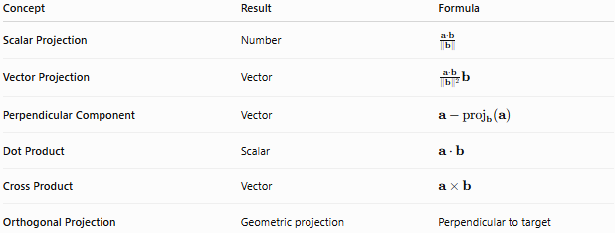
Concept | Result | Formula
Scalar Projection | Number | $$\frac{a⋅b}{∥b∥}$$
Vector Projection | Vector | $$\frac{a⋅b}{∥b∥^{2}}b$$
Perpendicular Component | Vector | $$a-{proj}_{b}(a)$$
Dot Product | Scalar | $$a⋅b$$
Cross Product | Vector | $$a×b$$
Orthogonal Projection | Geometric projection | Perpendicular to target

Key Points
# Source: AI Source: Provided by: [Data Path: Persons Table -> ID Column: 1, Name_En Column: Motasem Essam] -> From: [ChatGPT] on [7/25/2026]
- Vector projection finds the part of one vector that points in the direction of another vector.
- The main formula is:
$$\boxed{{proj}_{b}(a)=\frac{a⋅b}{∥b∥^{2}}b}$$
- Scalar projection gives the component's signed magnitude:
$$\boxed{{comp}_{b}(a)=\frac{a⋅b}{∥b∥}}$$
- The projection is parallel to $b$.
- The remaining component is perpendicular to $b$.
- If vectors are perpendicular, the projection is zero.
- If vectors are parallel, the projection is the entire vector being projected.
- Vector projection is the vector-based form of trigonometric projection.

Conclusion
# Source: AI Source: Provided by: [Data Path: Persons Table -> ID Column: 1, Name_En Column: Motasem Essam] -> From: [ChatGPT] on [7/25/2026]
Vector Projection is a fundamental operation that decomposes a vector into a component parallel to a chosen direction and a component perpendicular to that direction.
The central relationship is:
$$\boxed{a={proj}_{b}(a)+a_{⟂}}$$
with:
$$\boxed{{proj}_{b}(a)=\frac{a⋅b}{∥b∥^{2}}b}$$
This makes vector projection a key connection between geometric projection, trigonometry, dot products, orthogonality, coordinate geometry, and physics.

